**DAILY ONLINE ACTIVITIES SUMMARY**

|  |  |  |  |  |  |  |  |  |
| --- | --- | --- | --- | --- | --- | --- | --- | --- |
| **Date:** | **10-07-2020** | | | | | **Name:** | **Shiza Amreen.J** | |
| **Sem & Sec** | **4th Sem B Sec** | | | | | **USN:** | **4AL18CS078** | |
| **Online Test Summary** | | | | | | | | |
| **Subject** | | **Object Oriented Concepts** | | | | | | |
| **Max. Marks** | | **30** | | **Score** | | | **--** | |
| **Certification Course Summary** | | | | | | | | |
| **Course** | **Data Visualization Using Python** | | | | | | | |
| **Certificate Provider** | | | **GreatLearning** | | **Duration** | | | **3 Hours** |
| **Coding Challenges** | | | | | | | | |
| **Problem Statement: Not Given** | | | | | | | | |
| **Status:** | | | | | | | | |
| **Uploaded the report in Github** | | | | |  | | | |
| **If yes Repository name** | | | | | **Lockdown_coding**  <https://github.com/ShizaAmreen/Lockdown_coding> | | | |
| **Uploaded the report in slack** | | | | |  | | | |

Online Test Details:

Today we had OOC Descriptive IA – 1. I have attended the test and uploaded my answer script in Google Classroom.

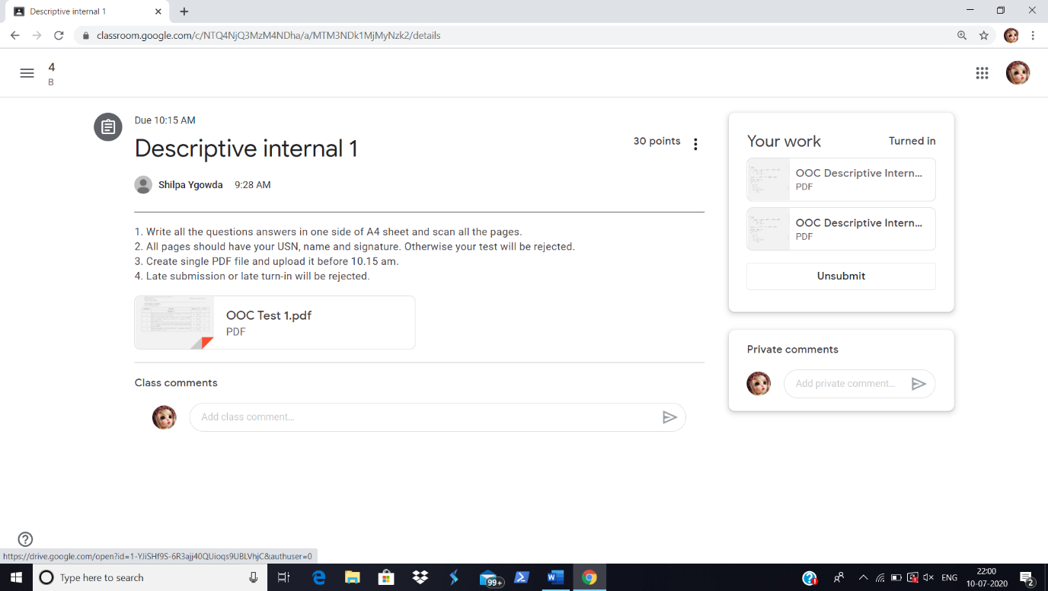

Certification Course Details:

Today, I have completed the course and got the Certificate of Completion.

Certificate:

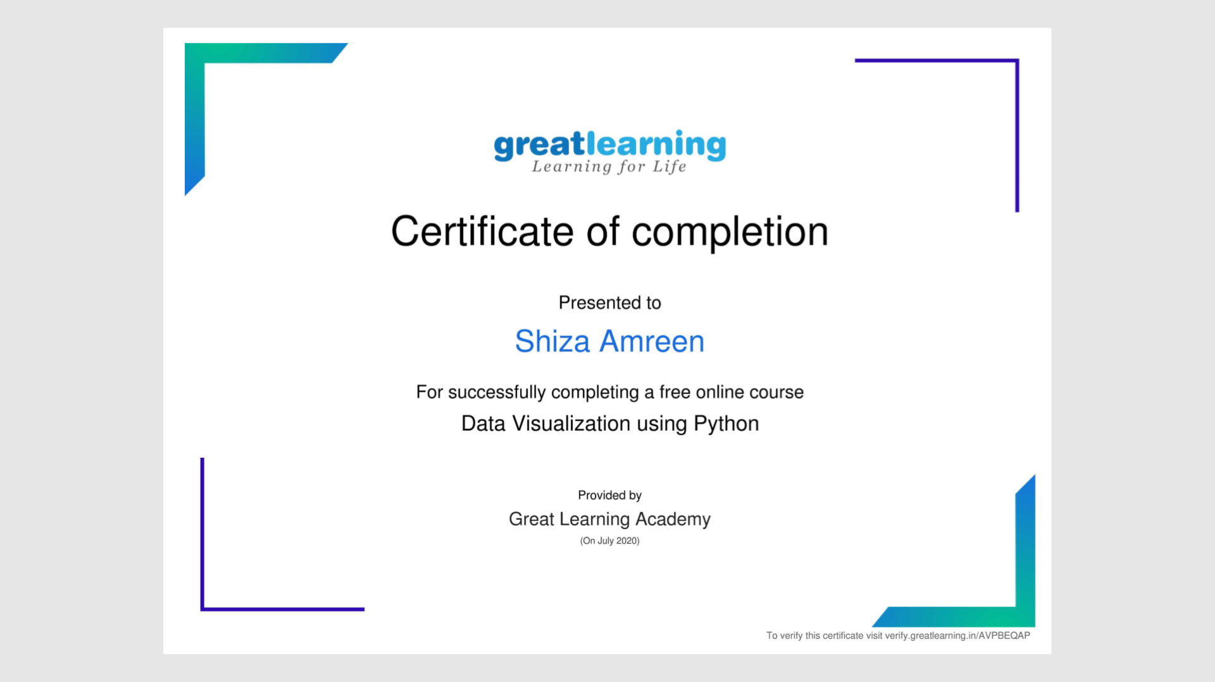



<https://olympus1.greatlearning.in/course_certificate/AVPBEQAP>